PATUMAHOE

1. Dataset coverage and descriptive statistics

Explanation
The main calculations are:
- Mean: arithmetic average.
- Median: central observation.
- Standard deviation: spread around the mean.
- Percentiles: values below which a stated percentage of observations fall.
- Coverage: available observations divided by all hours between the dataset’s first and last timestamps.
- Skewness: asymmetry of the distribution.
- IQR: 75th percentile minus 25th percentile.
This reproduces the previously reported coverage calculation. Missing hours are counted in the denominator, but are not replaced with zero.
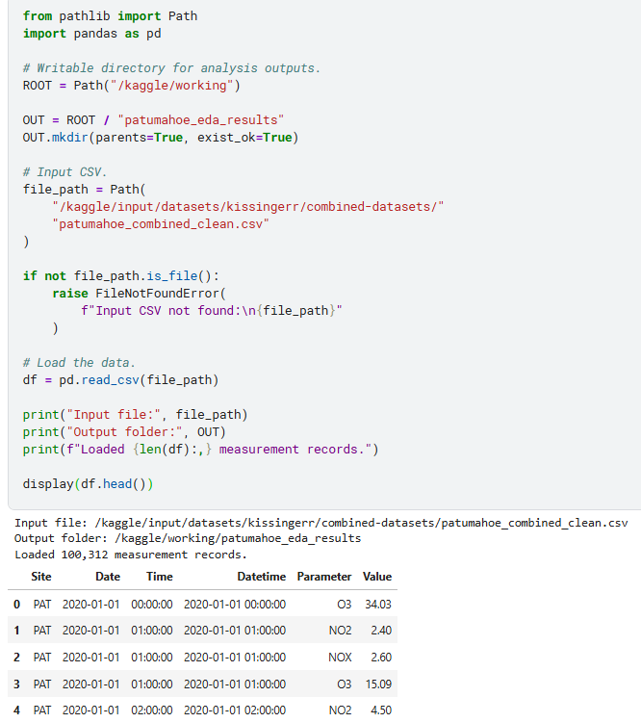

2. Daily patterns and concentrations over time

Explanation
Two different summaries are needed:
- Hour-of-day profile: groups all observations by clock hour to identify typical daily cycles.
- Daily time series: averages observations within each calendar day to show changes through the study period.
Daily means require at least 18 available hourly observations. That is an exploratory 75% completeness rule, not a claim of regulatory compliance.
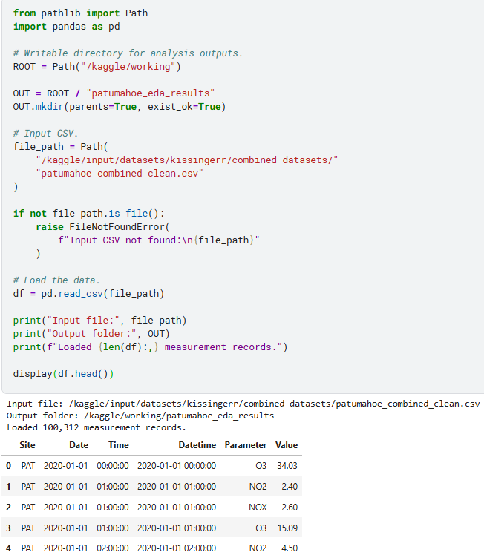

3. Weekly patterns

Explanation
This section calculates:
- Day-of-week patterns using eligible daily means.
- A chronological weekly series using Monday-start weeks.
Weekly averages require at least 126 of 168 hourly observations. First and last partial weeks may therefore be excluded.
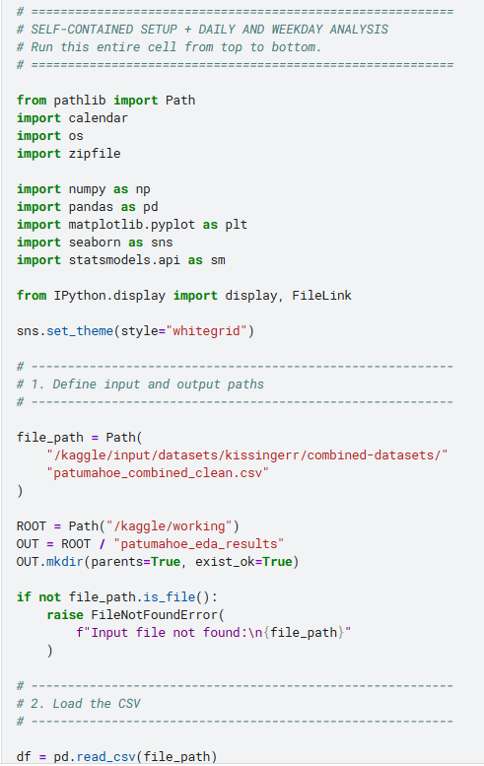

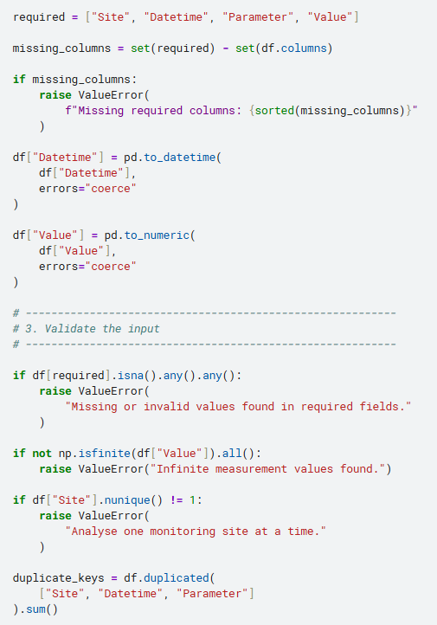

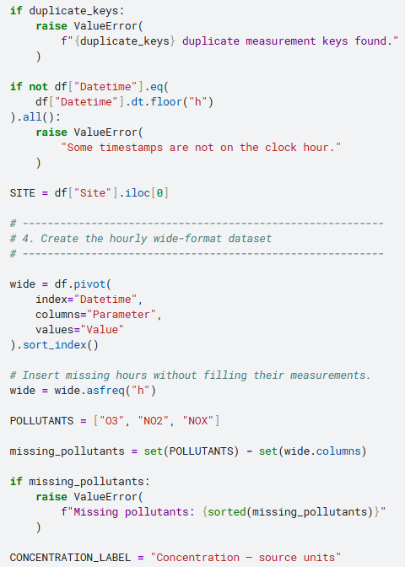

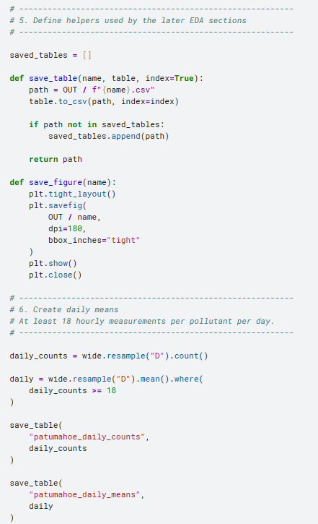

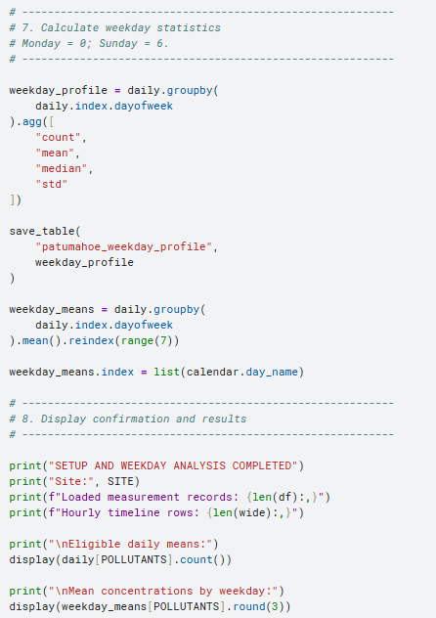

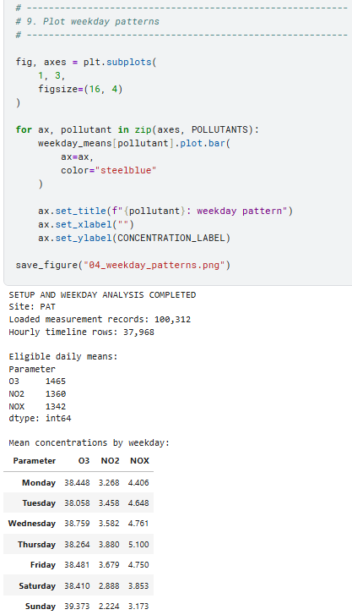

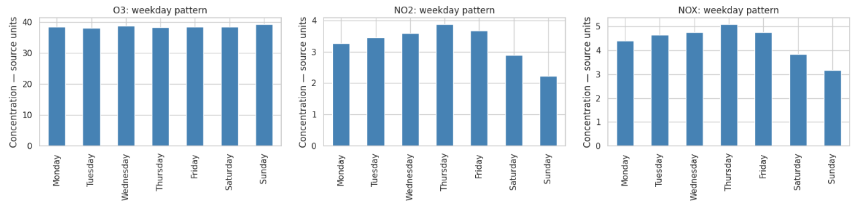

4. Seasonal and monthly patterns

Explanation
The seasonal analysis groups eligible daily means into:
- Summer: December–February.
- Autumn: March–May.
- Winter: June–August.
- Spring: September–November.
Each eligible day receives equal weight in the seasonal mean.
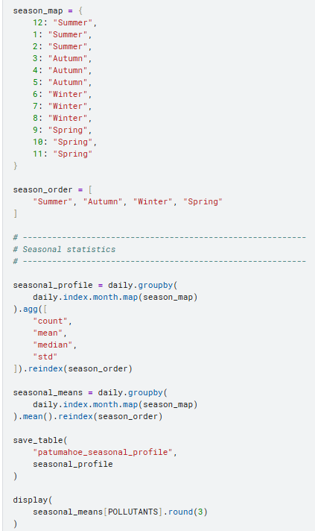
Monthly chronological means require at least 75% of the calendar month’s hourly observations.

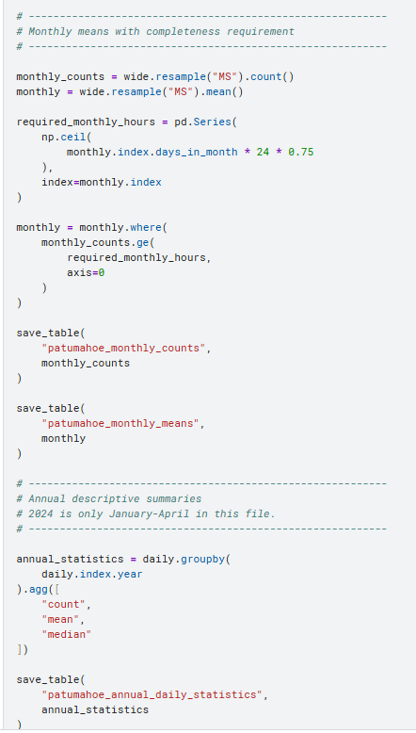

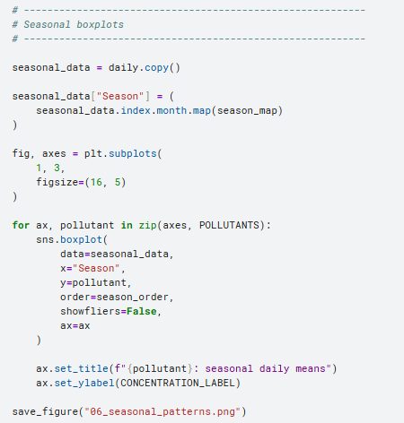

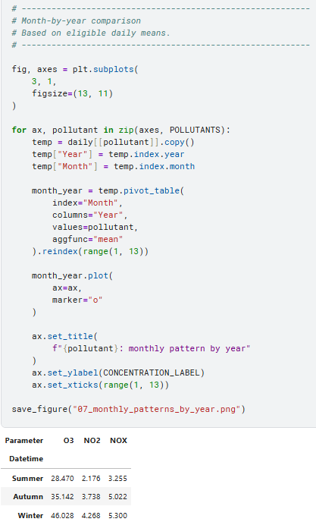

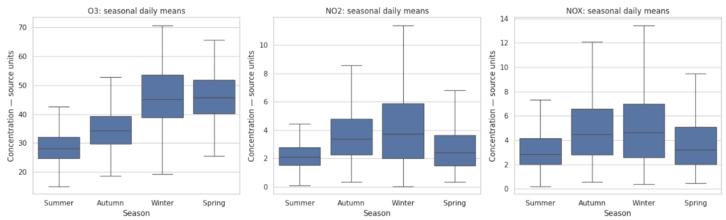

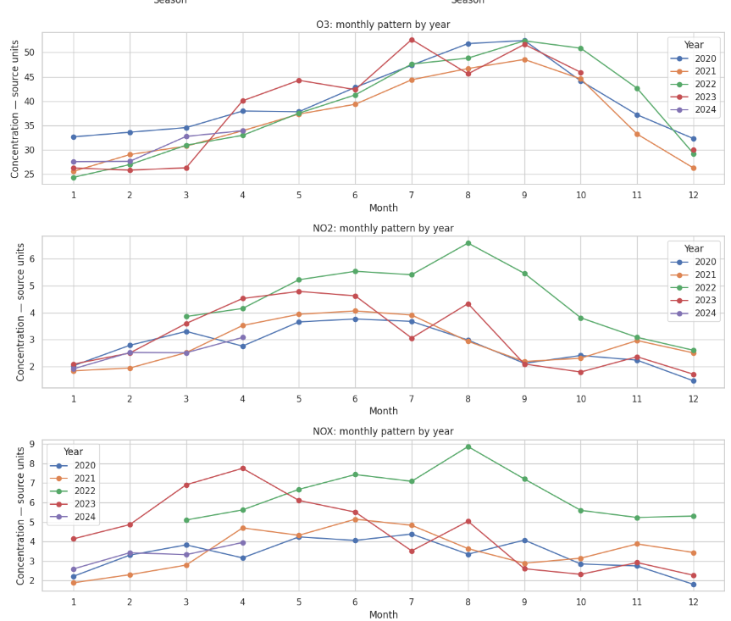

The seasonal table reproduces the higher spring/winter O₃ averages and higher winter nitrogen-oxide averages. Seasonal counts should be checked because the dataset does not cover all seasons equally.

5. Correlations between pollutants and meteorological variables

Explanation
The calculations are:
- Pearson correlation: linear association.
- Spearman correlation: association between ranked values.
- Pair counts: observations available for both variables.
- Month/hour-adjusted correlation: correlation after subtracting each variable’s typical calendar-month/hour mean.
The adjustment is:
Xadjusted,t=Xt−X‾month(t),hour(t)X_{\text{adjusted},t} = X_t-\overline{X}_{\text{month}(t),\text{hour}(t)}Xadjusted,t​=Xt​−Xmonth(t),hour(t)​
It removes average month/hour patterns. It is not a complete weather adjustment or causal analysis.
measurements.patumahoe_combined_clean.csv
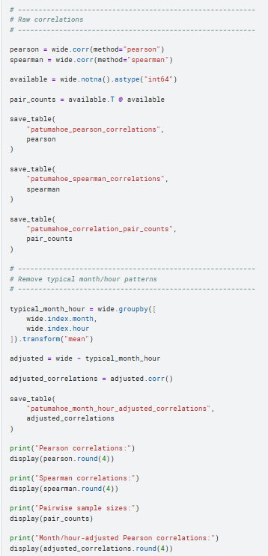

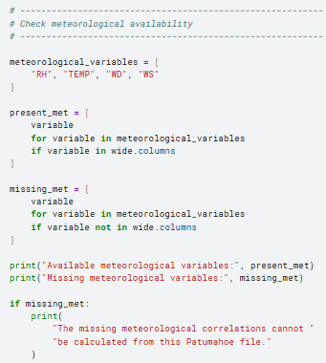

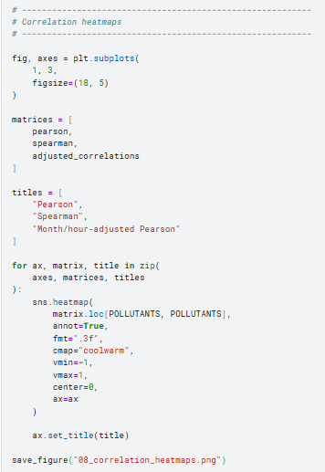

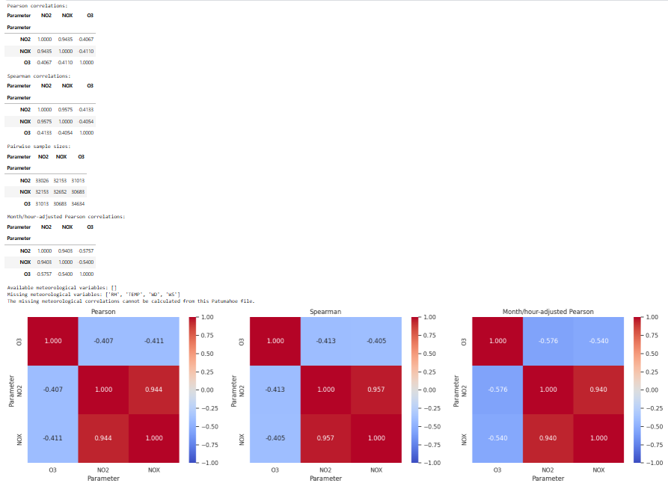

6. Lagged relationships between NO₂ and O₃

Explanation
The lag definition is:
r(k)=corr⁡(NO2(t),O3(t+k))r(k)= \operatorname{corr} \left(\mathrm{NO_2}(t),\mathrm{O_3}(t+k)\right)r(k)=corr(NO2​(t),O3​(t+k))
Therefore:
- k>0k>0k>0: NO₂ is measured before O₃.
- k<0k<0k<0: O₃ is measured before NO₂.
- k=0k=0k=0: simultaneous measurements.
Three versions are analysed:
- Original concentrations.
- Month/hour-adjusted concentrations.
- First differences: the change from the preceding hour.
Because the hourly grid includes missing hours, first differences are missing whenever either required hourly measurement is unavailable.
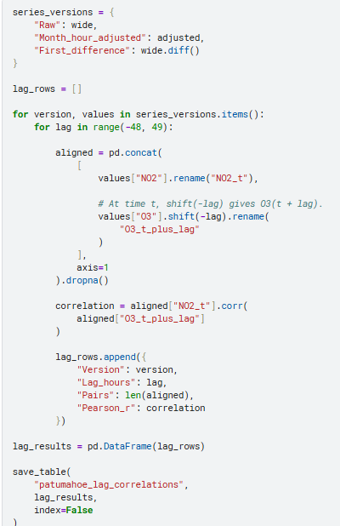

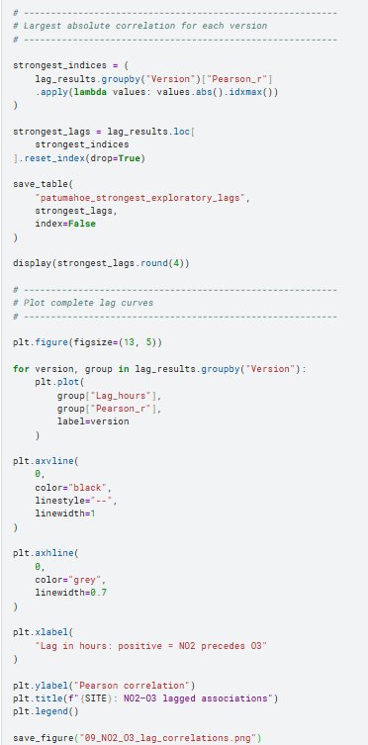

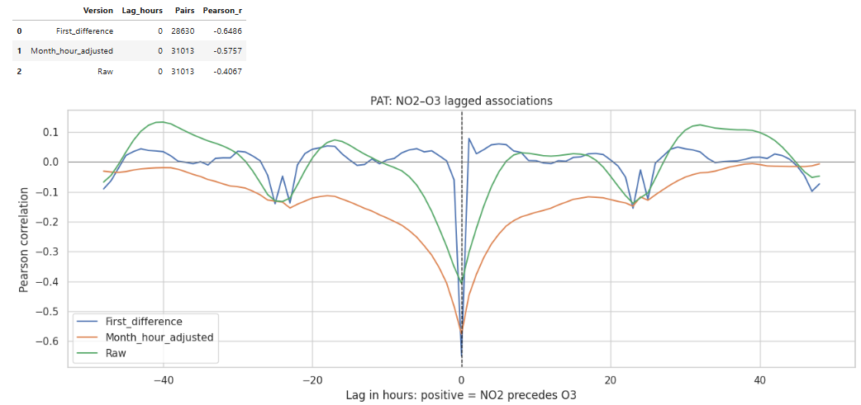

For this file, the largest absolute correlation occurs at zero lag in all three versions. The code reports the full curves and sample sizes rather than interpreting only the selected peaks.

7. Season-adjusted trends

Explanation
The model fitted separately for each pollutant is:
Yd=β0+β1TimeYearsd+∑m=212γmI(Monthd=m)+ϵdY_d = \beta_0 + \beta_1\mathrm{TimeYears}_d + \sum_{m=2}^{12} \gamma_m I(\mathrm{Month}_d=m) + \epsilon_dYd​=β0​+β1​TimeYearsd​+m=2∑12​γm​I(Monthd​=m)+ϵd​
Here:
- YdY_dYd​ is an eligible daily mean.
- β1\beta_1β1​ is the estimated annual concentration change.
- Month indicators account for average calendar-month differences.
- January is the reference month.
The confidence intervals use a 30-calendar-day Newey–West-style HAC covariance calculation. The longer code below preserves actual calendar gaps: missing days are not compressed into adjacent observations.
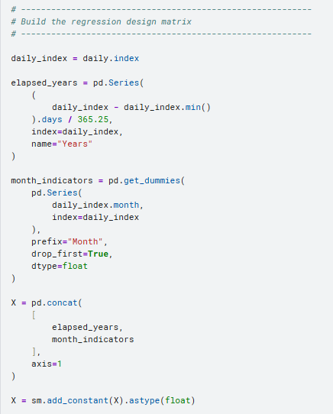
This is the calculation used for the trend results previously reported.

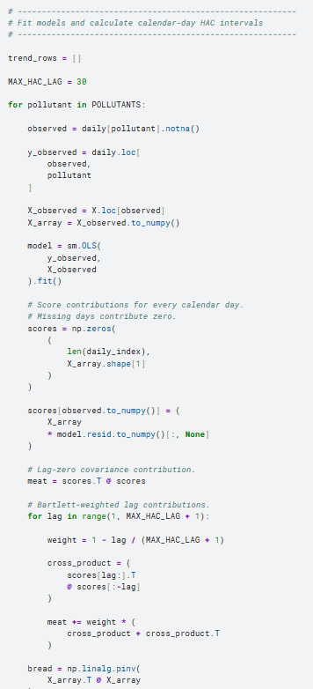

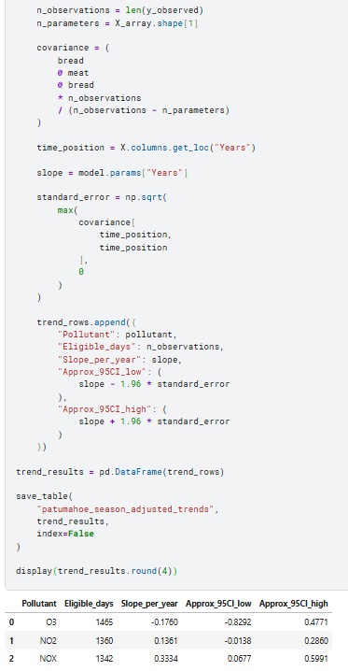

How to interpret the output
- Positive slope: increasing concentration under this model.
- Negative slope: decreasing concentration.
- Interval including zero: the estimated slope is not clearly distinguishable from zero using this approximate interval.
- Interval excluding zero: evidence of a nonzero slope under the model assumptions.
For your file, the NOx interval is above zero; the O₃ and NO₂ intervals include zero. This does not establish an emissions trend or adjust for meteorology.patumahoe_combined_clean.csv

8. Statistical anomalies and unusually high pollution episodes

Explanation
Two independent screening methods were used.

A. Statistical anomalies
For each calendar-month/hour group:
- Calculate its median.
- Calculate the median absolute deviation, or MAD.
- Calculate a robust score:
zrobust=0.67448975x−median(x)MAD(x)z_{\text{robust}} = 0.67448975 \frac{x-\mathrm{median}(x)} {\mathrm{MAD}(x)}zrobust​=0.67448975MAD(x)x−median(x)​
Flag observations when:
- ∣zrobust∣>4.5|z_{\text{robust}}|>4.5∣zrobust​∣>4.5.
- The baseline group contains at least 20 observations.
Groups with zero MAD are not scored.

B. High-concentration episodes
- Calculate the full-period 99th percentile for each pollutant.
- Flag readings strictly greater than that percentile.
- Group consecutive flagged hours into episodes.
- Split episodes whenever an hour is missing or not above the threshold.

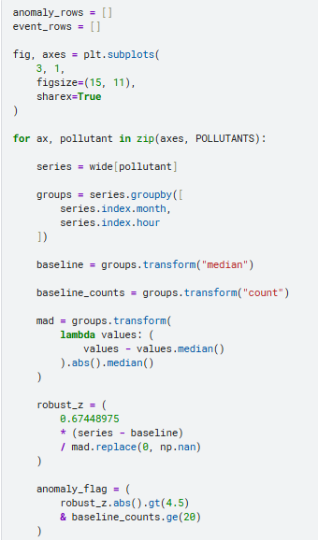

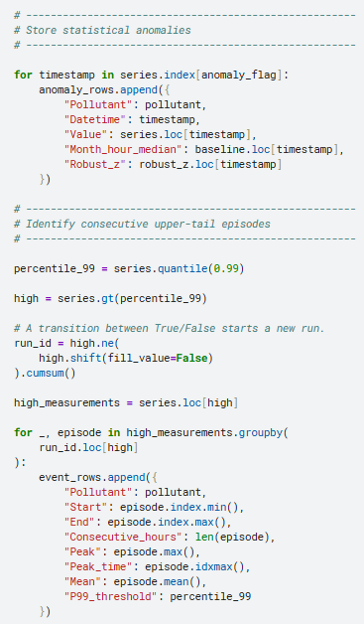

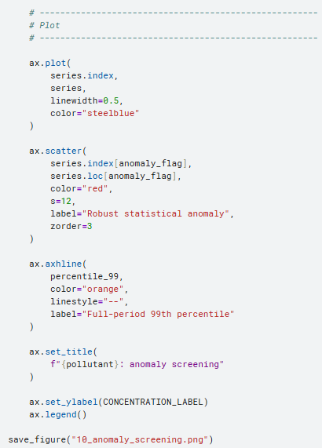

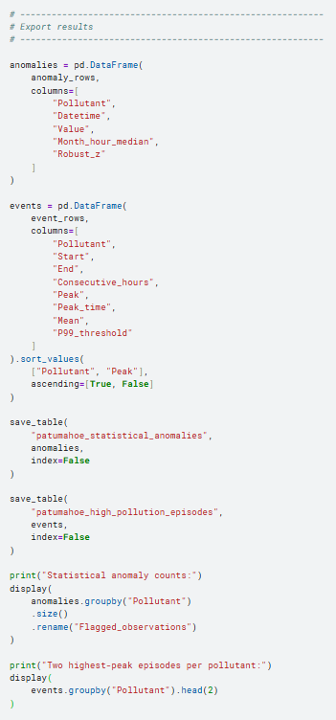

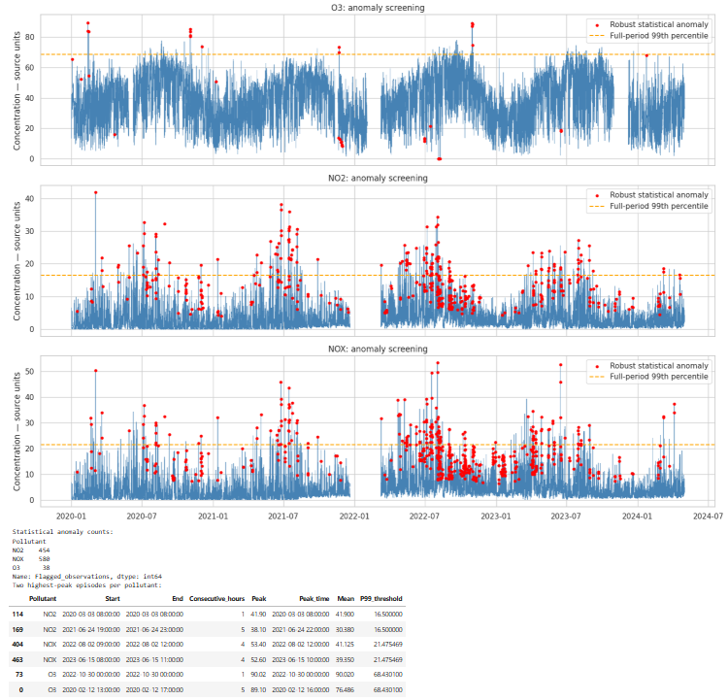

This reproduces 38 O₃, 454 NO₂, and 580 NOx statistical flags. These include high and low anomalies; the upper-tail episode table is a separate output.patumahoe_combined_clean.csv
Neither method identifies a regulatory exceedance. Keep the flagged records and investigate their context rather than automatically deleting them.

9. Export and download the results

Explanation
The preceding sections save 19 CSV tables and 10 PNG figures.
This final cell packages those files into one ZIP and displays a download link. It packages the outputs generated during this run, not the original cleaned input file.

Analysis settings to report in your methodology
Setting | Value used
Missing hourly measurements | Retained as missing; no interpolation
Daily-mean completeness | At least 18 hours
Weekly-mean completeness | At least 126 hours
Monthly-mean completeness | At least 75% of calendar-month hours
Seasons | Southern Hemisphere calendar seasons
Raw correlations | Pairwise available observations
Temporal correlation adjustment | Subtract calendar-month/hour means
Lag search | −48 to +48 hours
Trend model | Daily concentration against time and calendar-month indicators
Trend uncertainty | Approximate 95% interval; 30-calendar-day HAC covariance
Statistical anomaly threshold | Absolute robust score greater than 4.5
Minimum anomaly baseline size | 20 observations per month/hour group
High-episode threshold | Strictly above the full-period 99th percentile
These settings make the analysis reproducible. They should be presented as exploratory choices, with sensitivity checks before using the findings for confirmatory research conclusions.

QUEEN STREET
The main findings are:
- NO₂ shows morning and evening peaks, higher weekday concentrations, and higher winter concentrations.
- NO₂ has weak negative correlations with RH, temperature, and wind speed; associations with wind direction are clearer when analysed using directional components and sectors.
- The season-adjusted NO₂ trend is downward, although the year-by-year pattern is not a steady decline.
- One wind-speed reading is unusually large and needs source verification.
- Queen Street has no O₃ measurements. The NO₂–O₃ lag analysis therefore compares Queen Street NO₂ with Patumahoe O₃ and must be interpreted as a cross-site analysis.queen_street_combined_clean.csv+1

1. Dataset checks and preparation
Your Queen Street file contains 185,235 measurement records from site QUS, spanning 1 January 2019 to 23 August 2023 at 04:00. It contains NO2, RH, TEMP, WD, and WS, with no missing fields or duplicate timestamp–parameter keys in the uploaded CSV.queen_street_combined_clean.csv
Two preparation decisions matter:

Sub-hourly relative humidity
RH includes readings at minutes 30, 40, and 50, as well as on the hour. I aggregated available readings within each clock-hour bin rather than dropping the sub-hourly records. This produces 23,500 hourly RH values from 25,700 original RH readings. RH begins on 1 December 2020, substantially later than the other variables.queen_street_combined_clean.csv
An hourly RH value may therefore represent one or several retained observations. The source’s measurement-interval conventions should be checked before treating these as equivalent to independently validated hourly averages.

Circular wind direction
Wind direction was analysed with circular means, sine/cosine components, and wind sectors—not ordinary averages of degrees. For example, 359° and 1° should average near north, not south.wikipedia
Missing hourly measurements were left missing; no interpolation was applied.

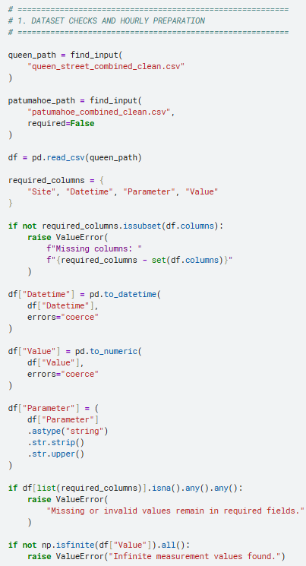

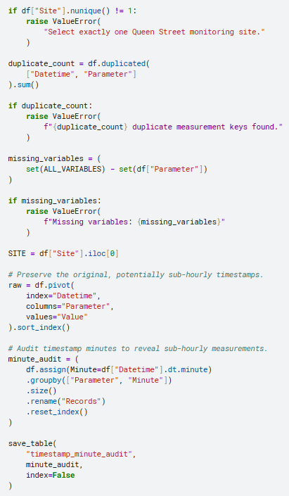

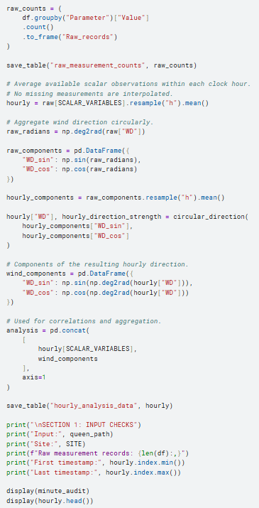

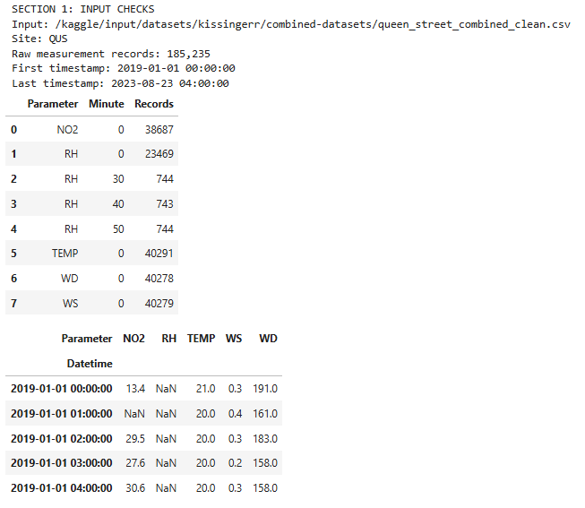

2. Descriptive statistics
The following statistics use the hourly analysis dataset. Values remain in the source numerical units because the cleaned CSV does not document units. RH, temperature, wind direction, and wind speed are meteorological measurements, not pollutant concentrations.queen_street_combined_clean.csv
Statistic | NO₂ | RH | Temperature | Wind speed
Available hourly values | 38,687 | 23,500 | 40,291 | 40,279
Mean | 32.15 | 65.28 | 17.11 | 0.532
Median | 26.40 | 66.00 | 17.00 | 0.500
Standard deviation | 23.03 | 11.84 | 3.95 | 0.396
Minimum | 0.00 | 27.80 | 0.00 | 0.000
95th percentile | 77.70 | 83.20 | 23.00 | 1.100
99th percentile | 109.30 | 85.90 | 25.00 | 1.500
Maximum | 200.37 | 89.30 | 29.00 | 52.800
Coverage within each variable’s observed span | 95.09% | 98.39% | 99.03% | 99.00%
Calculated from the uploaded Queen Street measurements after hourly aggregation. RH’s coverage refers to its shorter monitoring span, not the entire 2019–2023 period.queen_street_combined_clean.csv
NO₂ is right-skewed: its mean exceeds its median, and its upper tail contains occasional high readings. Wind speed is strongly affected by the isolated maximum discussed in Section 8.queen_street_combined_clean.csv
For wind direction:
- Circular mean: 197.99°.
- Mean resultant length: 0.463.
- Available hourly directions: 40,278.queen_street_combined_clean.csv
The resultant length measures directional concentration: values nearer one indicate more tightly clustered directions. The direction distribution is therefore not adequately described by its mean alone.

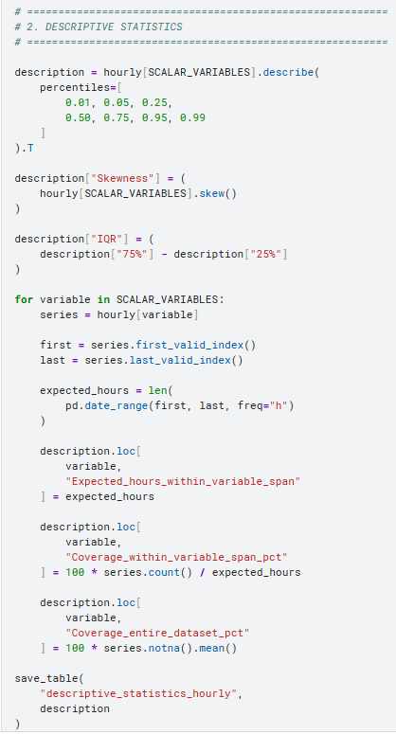

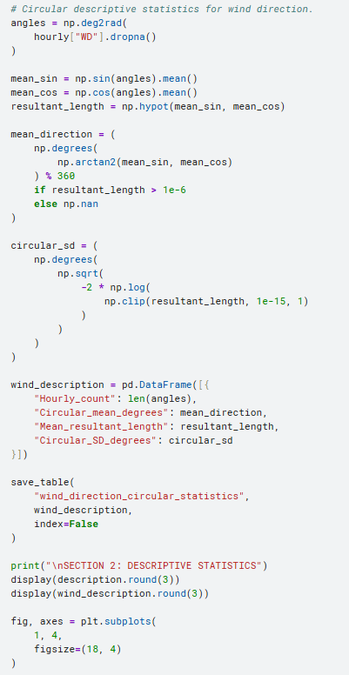

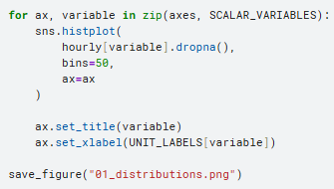

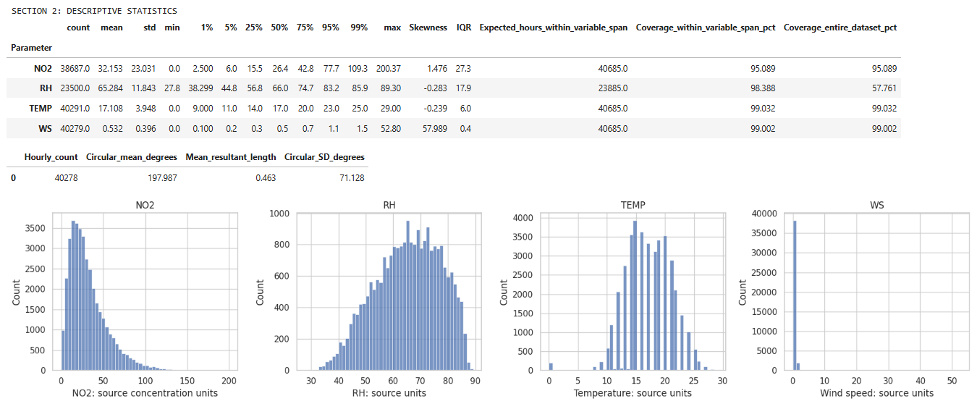

3. Daily patterns
The pooled hour-of-day profiles show the following:
Variable | Observed daily pattern
NO₂ | Highest hourly mean at 09:00: 44.93; another local peak at 18:00: 42.58; lowest at 03:00: 13.06
RH | Approximately 72.05 at 05:00–06:00, falling to 55.64 at 12:00
Temperature | Lowest hourly mean at 06:00: 15.36; highest at 12:00: 19.41
Wind speed | Approximately 0.46 in the early morning, rising to 0.68 at 13:00
These averages use the timestamps as supplied, without timezone conversion.queen_street_combined_clean.csv
The NO₂ morning and evening peaks are clear descriptive features. However, the dataset alone does not establish how much of those peaks comes from traffic, atmospheric mixing, or other sources.queen_street_combined_clean.csv
The plotting notebook includes hourly, daily, and weekly time-series panels for all five variables. Wind direction is plotted as directional observations and circular summaries to avoid misleading lines across the 0°/360° boundary.

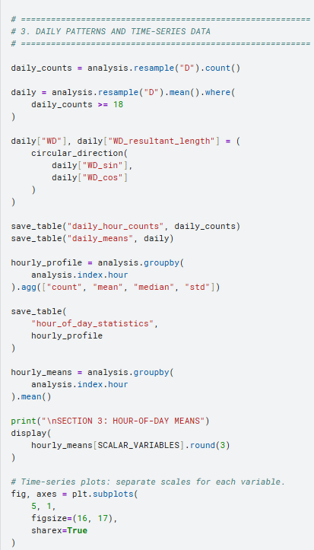

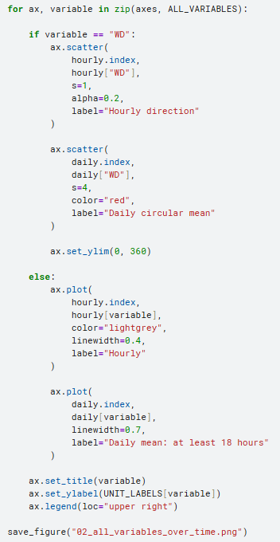

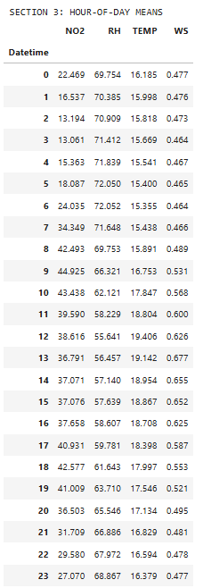

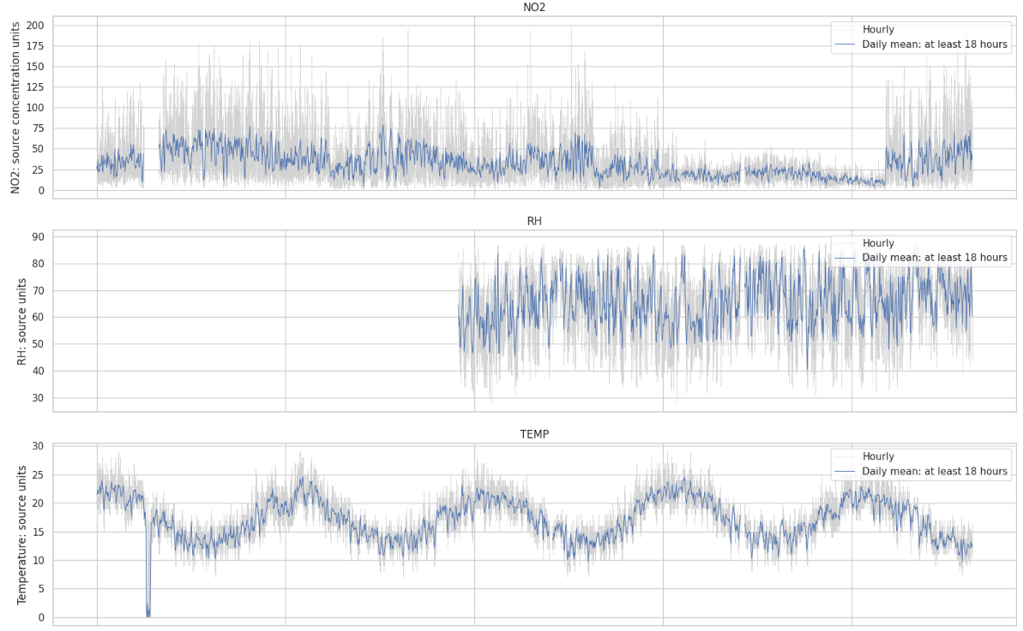

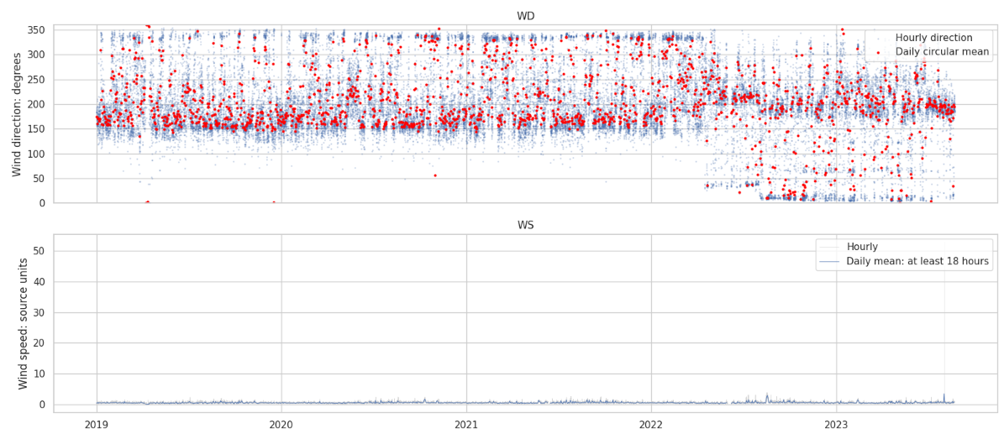

4. Weekly patterns
Weekday summaries use daily means with at least 18 available hourly measurements for the relevant variable.
Day | NO₂ | RH | Temperature | Wind speed
Monday | 31.70 | 65.97 | 17.13 | 0.53
Tuesday | 34.07 | 65.87 | 17.24 | 0.55
Wednesday | 35.90 | 64.94 | 17.06 | 0.54
Thursday | 35.19 | 64.38 | 17.02 | 0.53
Friday | 34.36 | 64.69 | 17.04 | 0.53
Saturday | 29.02 | 65.04 | 17.11 | 0.52
Sunday | 25.21 | 65.94 | 17.18 | 0.52
Calculated from eligible daily means.queen_street_combined_clean.csv
NO₂ has a more pronounced weekday pattern than the meteorological variables: Wednesday is highest and Sunday lowest. These are descriptive differences, not results from a formal test of weekday effects.queen_street_combined_clean.csv
Chronological weekly means are also included in the results, requiring at least 126 hourly observations per variable per week.

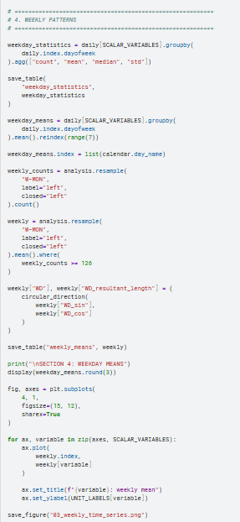

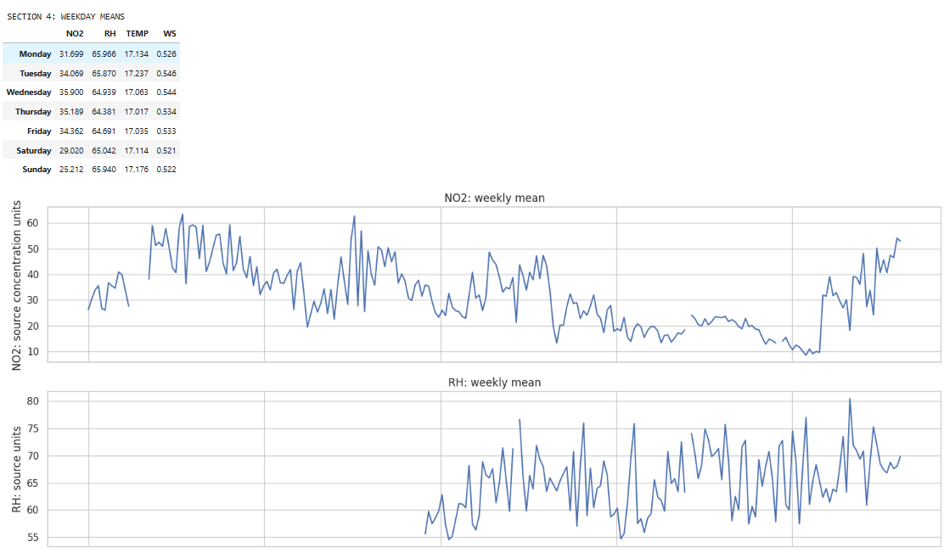

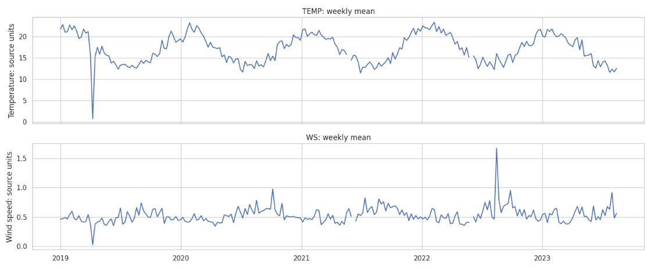

5. Seasonal patterns
The seasonal summaries use Southern Hemisphere seasons and eligible daily means.
Season | NO₂ | RH | Temperature | Wind speed
Summer: December–February | 25.48 | 62.53 | 20.99 | 0.50
Autumn: March–May | 30.70 | 65.16 | 17.83 | 0.45
Winter: June–August | 39.51 | 68.64 | 13.49 | 0.59
Spring: September–November | 32.79 | 64.74 | 16.15 | 0.61
Calculated from days with at least 18 observed hours for each variable.queen_street_combined_clean.csv
NO₂ is highest in winter and lowest in summer. Winter also has the highest RH and lowest temperature. These simultaneous seasonal patterns do not, by themselves, establish which weather variables explain NO₂ variation.queen_street_combined_clean.csv
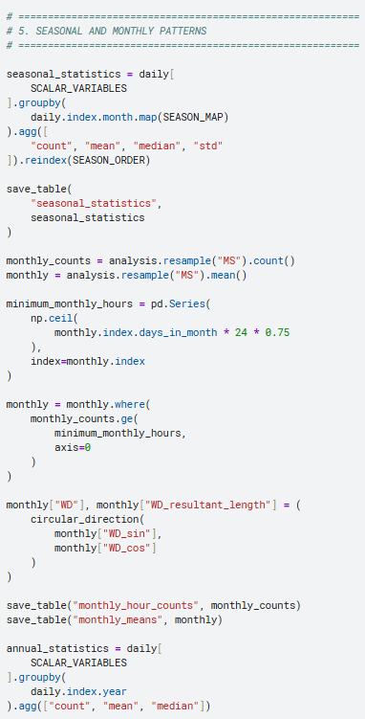
Coverage differs between variables and seasons, particularly because RH starts in December 2020 and the dataset ends during August 2023. The supplied tables include counts so these differences can be inspected.queen_street_combined_clean.csv

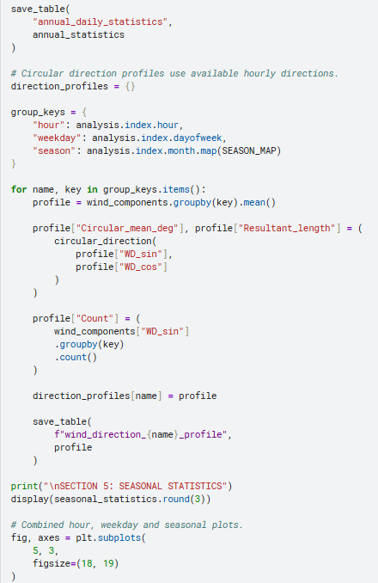

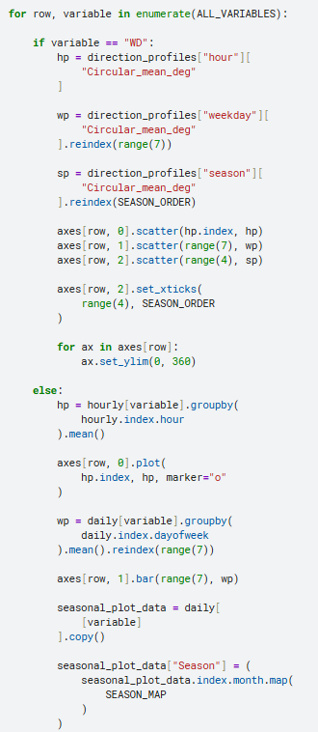

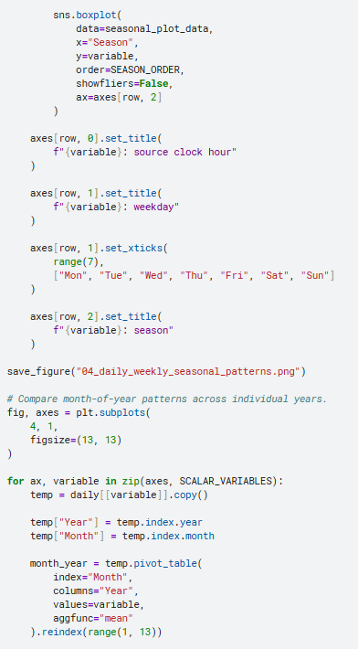

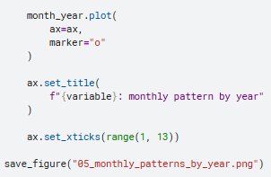

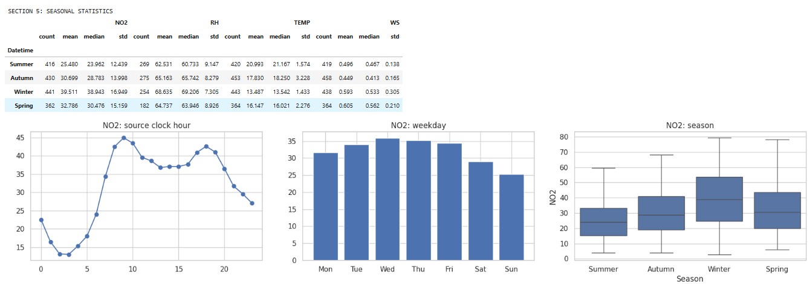

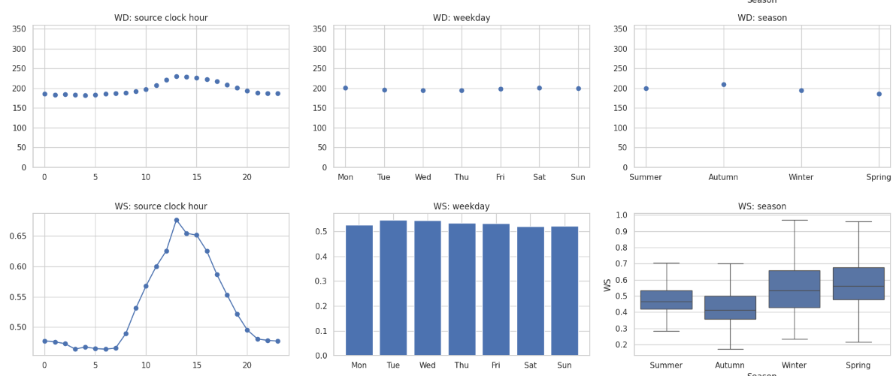

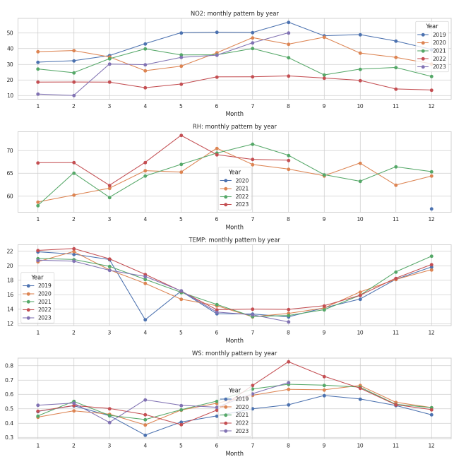

6. Correlations with meteorological variables

Pearson correlations
Variable pair | Pearson rrr
NO₂–RH | −0.129
NO₂–temperature | −0.100
NO₂–wind speed | −0.091
RH–temperature | −0.288
RH–wind speed | −0.006
Temperature–wind speed | −0.007
Correlations use pairwise available hourly values. Sample sizes differ: NO₂–RH uses 22,871 pairs, whereas NO₂–wind speed uses 38,536 pairs.queen_street_combined_clean.csv
The raw linear associations between NO₂ and these scalar meteorological variables are weak. They should not be interpreted as showing that weather is unimportant: pairwise correlations do not capture all nonlinear, directional, or interacting effects.

After removing typical month/hour patterns
I subtracted each variable’s average for its calendar-month/hour combination and recalculated correlations.
Variable pair | Raw Pearson rrr | Month/hour-adjusted rrr
NO₂–RH | −0.129 | −0.084
NO₂–temperature | −0.100 | −0.051
NO₂–wind speed | −0.091 | −0.199
Calculated from the hourly dataset and its departures from typical month/hour values. This is temporal adjustment, not full meteorological adjustment.queen_street_combined_clean.csv
The negative NO₂–wind-speed association becomes stronger after removing those average temporal patterns. The RH and temperature associations become weaker.queen_street_combined_clean.csv

Wind direction
Using directional components:
Pair | Raw Pearson rrr | Month/hour-adjusted rrr
NO₂–sin(WD) | +0.214 | +0.314
NO₂–cos(WD) | −0.229 | −0.285
These components describe different aspects of direction; neither is a complete wind-direction association on its own.queen_street_combined_clean.csv
Wind-sector summaries provide a more intuitive comparison:
- Southeast: mean NO₂ 40.54.
- South: 37.11.
- Northeast: 22.02.
- North: 23.68.queen_street_combined_clean.csv
The sector analysis excludes zero-wind-speed observations. Sector counts differ substantially, and the results do not identify pollution-source locations without further analysis.
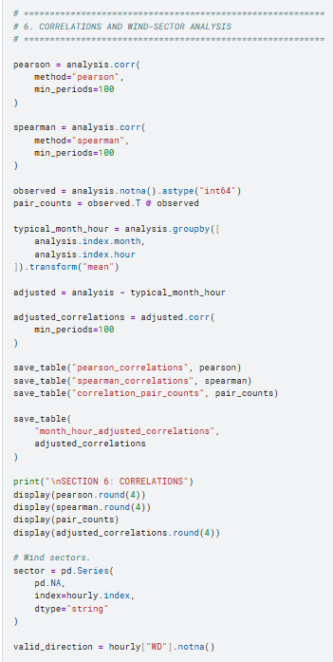

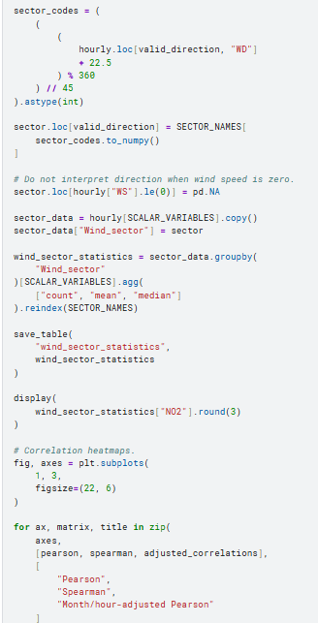

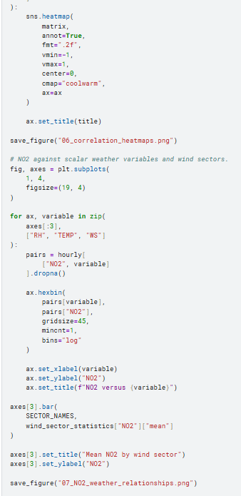

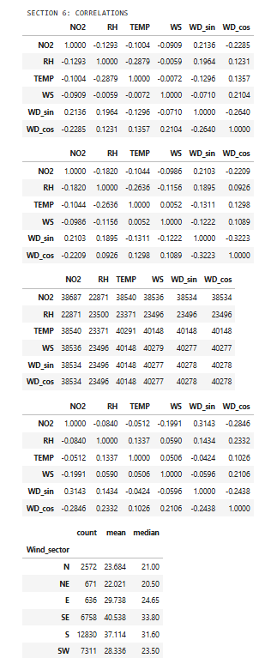

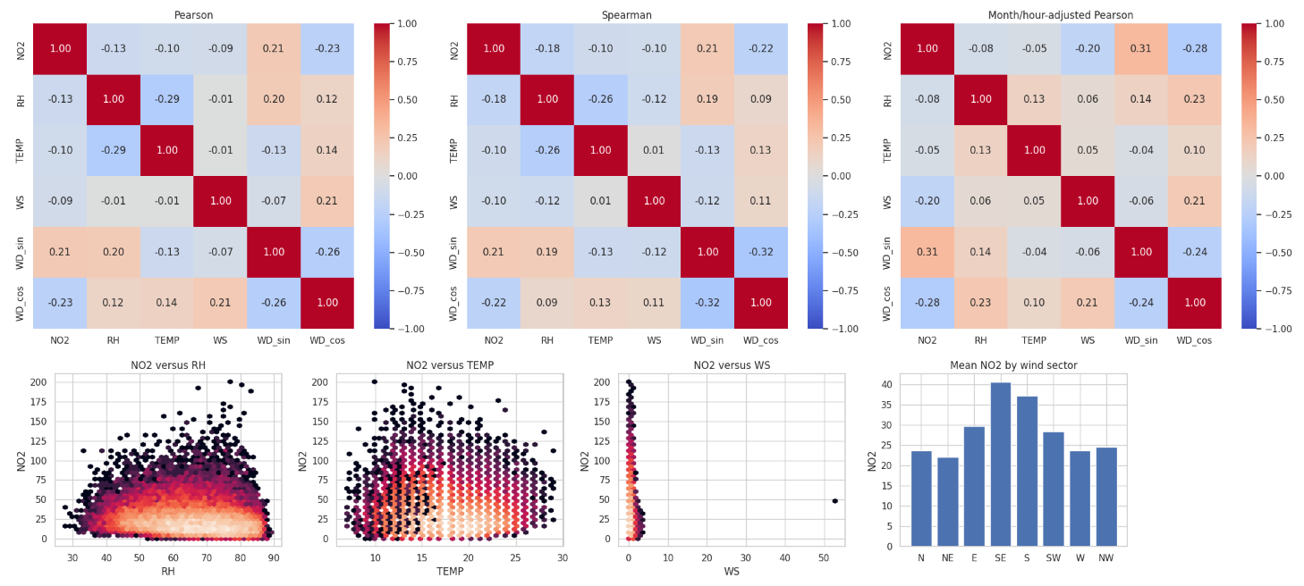

7. Lagged NO₂–O₃ relationships

This analysis compares different sites
Queen Street contains NO₂ but no O₃. I therefore aligned Queen Street NO₂ with Patumahoe O₃ over their overlapping period. These are not the same-site relationships reported previously for Patumahoe.queen_street_combined_clean.csv+1
The lag definition is:
r(k)=corr⁡(NO2QueenStreet(t),O3Patumahoe(t+k))r(k)=\operatorname{corr} \left( \mathrm{NO_2}_{QueenStreet}(t), \mathrm{O_3}_{Patumahoe}(t+k) \right)r(k)=corr(NO2​QueenStreet​(t),O3​Patumahoe​(t+k))
A positive lag means Queen Street NO₂ precedes Patumahoe O₃.
Analysis version | Lag with largest absolute correlation | Pearson rrr
Raw concentrations | −45 hours | +0.267
Month/hour-adjusted concentrations | −46 hours | +0.068
Hour-to-hour changes | 0 hours | −0.080
Calculated across lags from −48 to +48 hours, retaining gaps and using available pairs.queen_street_combined_clean.csv+1
The simultaneous raw correlation is +0.182, falling to −0.024 after month/hour adjustment. The adjusted lag correlations are also small. This indicates that the raw cross-site associations are sensitive to shared temporal patterns and do not establish a useful transport delay.queen_street_combined_clean.csv+1
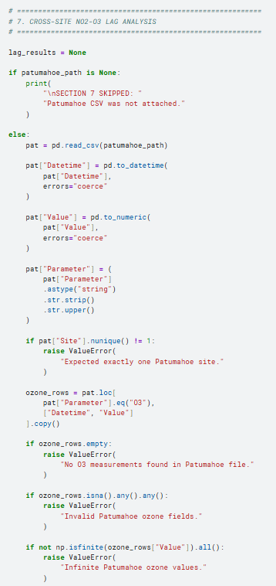
The source timestamp conventions have not been verified. In addition, autocorrelation and searching many lags can produce misleading peaks, so the −45-hour result should not be interpreted as a physical travel time.

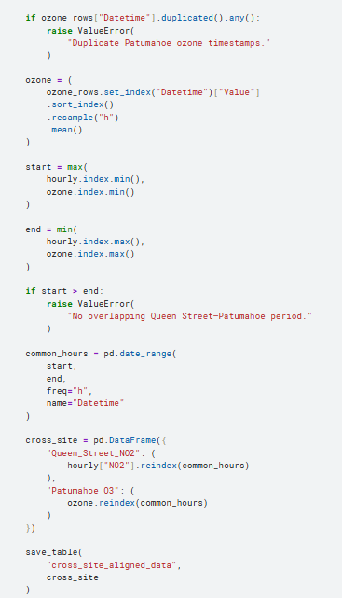

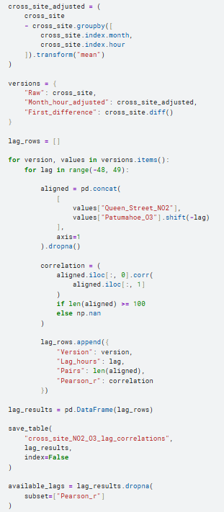

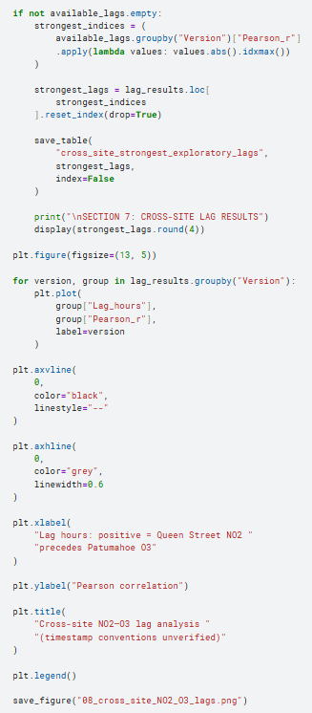

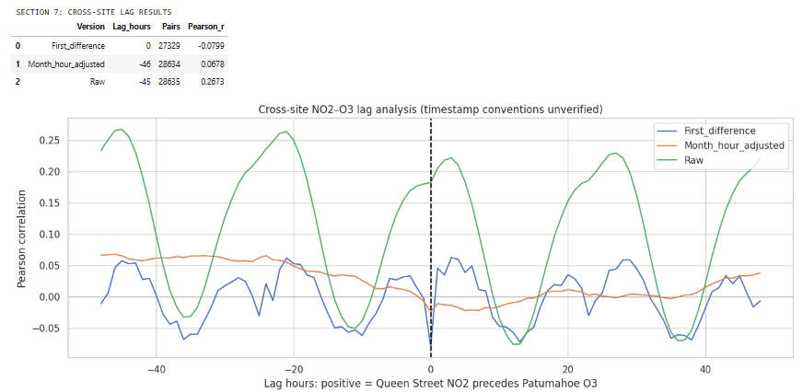

8. Trends, anomalies, and unusual events

Season-adjusted trends
Daily-mean regressions include elapsed time and calendar-month indicators. Approximate 95% intervals use a 30-calendar-day autocorrelation-robust covariance calculation.
Variable | Estimated change per year | Approximate 95% interval
NO₂ | −5.467 | −7.114 to −3.819
RH | +1.901 | +1.017 to +2.785
Temperature | +0.145 | −0.050 to +0.339
Wind speed | +0.021 | +0.010 to +0.032
Changes are in source numerical units per year. RH is estimated over its shorter observed period. No linear trend was fitted to raw wind-direction degrees.queen_street_combined_clean.csv
The NO₂ model indicates an overall decline, but the observed annual daily-mean averages are not monotonically decreasing:
Year | Average eligible daily NO₂
2019 | 44.40
2020 | 36.78
2021 | 30.91
2022 | 18.50
2023, partial year | 30.01
These averages have differing coverage, and 2023 ends in August. They show why a single slope should not be presented as a steady year-by-year reduction.queen_street_combined_clean.csv
The trends are observational, not causal or emissions-adjusted estimates. In particular, the wind-speed trend needs sensitivity checks because of the extreme reading below.

Wind-speed reading requiring verification
The largest wind-speed value is 52.8 at 13:00 on 2 August 2023. The next-largest value is 3.8—a substantial discontinuity.queen_street_combined_clean.csv
I retained it in the primary analysis and performed a separate sensitivity check:
Calculation | All retained readings | Omitting only the maximum WS reading
Wind-speed mean | 0.532 | 0.530
Wind-speed standard deviation | 0.396 | 0.298
NO₂–WS Pearson correlation | −0.091 | −0.126
This comparison is a diagnostic, not justification for deleting the value. Verify its units, source record, and instrument-quality information first.queen_street_combined_clean.csv

Statistical anomaly screening
Using an absolute robust score greater than 4.5 against month/hour medians, with at least 20 baseline observations, the screen flagged:
- NO₂: 149 observations.
- Temperature: 222 observations.
- Wind speed: 864 observations.
- RH: no observations under this particular rule.queen_street_combined_clean.csv
The wind-speed count should be treated cautiously: a tightly clustered or rounded baseline can produce a small median absolute deviation and many flags. These are screening results, not confirmed errors.

High-NO₂ episodes
Episodes are consecutive hours strictly above NO₂’s full-period 99th percentile of 109.3.
Episode | Hours above threshold | Peak NO₂ | Peak timestamp
10 August 2023, 09:00–10:00 | 2 | 200.37 | 09:00
7 July 2021, 09:00–10:00 | 2 | 197.60 | 09:00
25 August 2020, 12:00 | 1 | 194.10 | 12:00
19 April 2021, 10:00 | 1 | 193.30 | 10:00
7 July 2020, 16:00–17:00 | 2 | 184.40 | 16:00
These are high readings relative to this dataset, not verified pollution incidents or regulatory exceedances. The episode table also includes the available RH, temperature, wind-speed, and circular wind-direction context.queen_street_combined_clean.csv

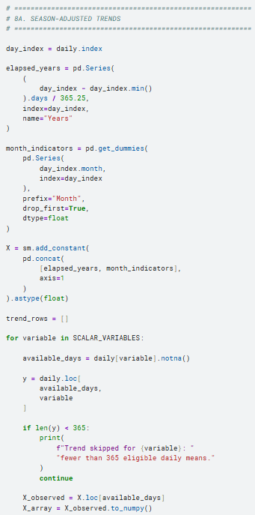

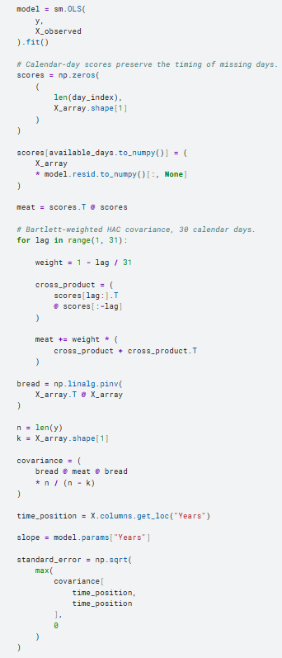

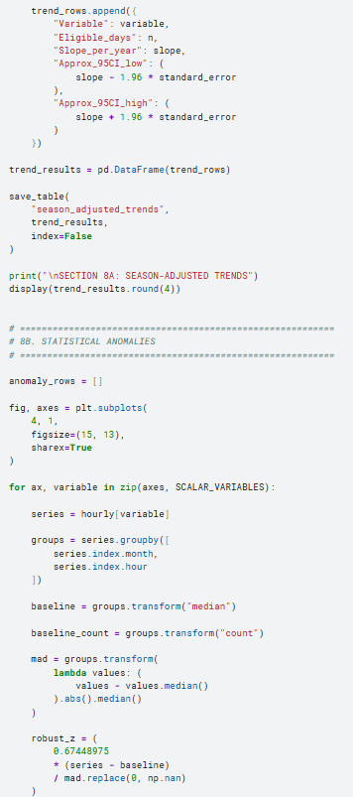

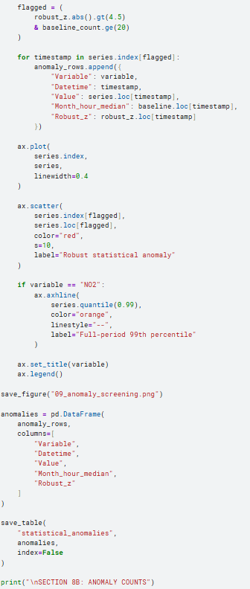

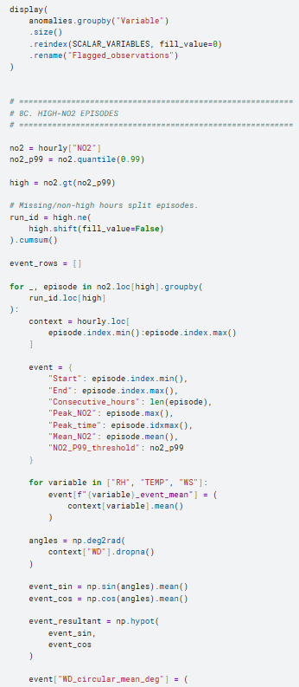

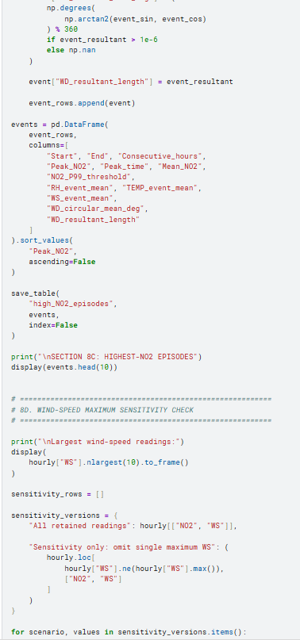

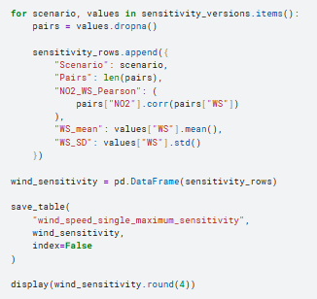

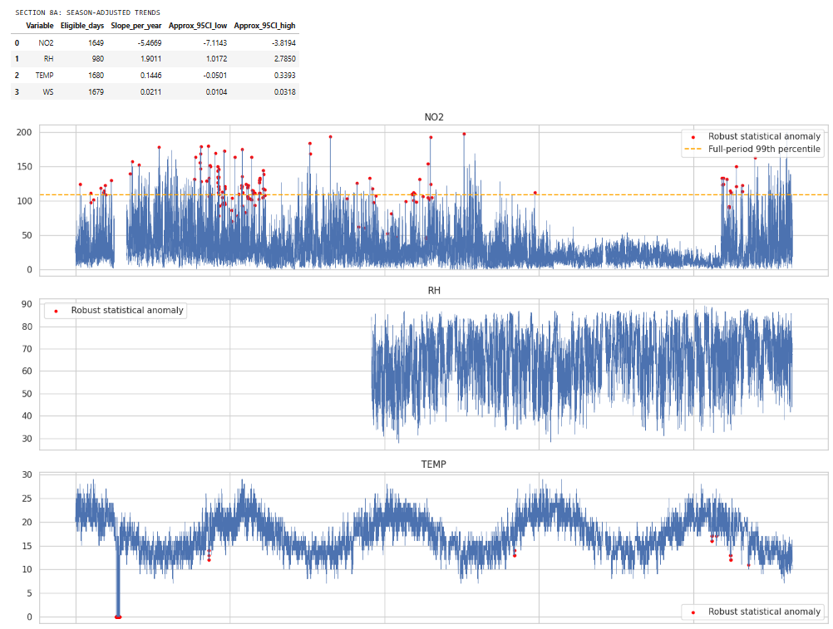

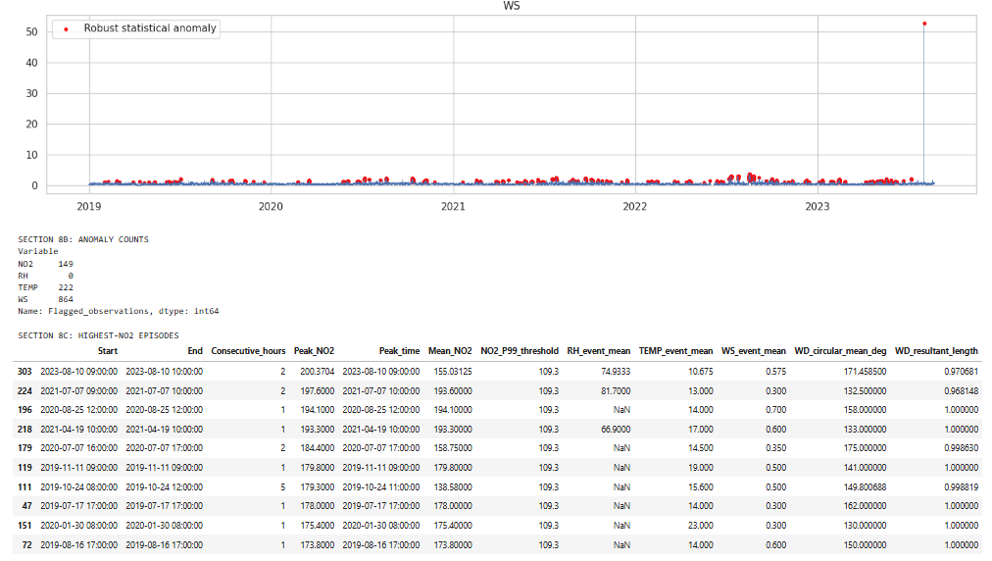

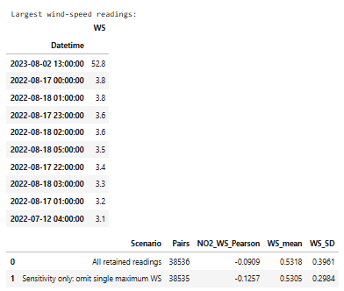

9. Generated files and plots
The attached deliverables are:
- A results ZIP containing 29 CSV tables, methodological notes, the complete Python script, and the Kaggle notebook.
- A standalone Kaggle notebook.
- A standalone Python script.
The numerical analysis has been executed. The plots have not been rendered here; the notebook generates eight figure files covering:
- All five variables over time.
- Daily, weekday, and seasonal patterns.
- Pearson, Spearman, and temporally adjusted correlations.
- NO₂–weather relationships and wind sectors.
- Cross-site NO₂–O₃ lag curves.
- Statistical anomalies.
- Monthly patterns by year.
- Variable distributions.

